**WS04-JAVA,JAVAC -VERSION**

**DATE:** 10th november 2021

**JAVA, JAVAC -VERSION**

**1 ALMACHE LITARDO ANDERSON MOISES**

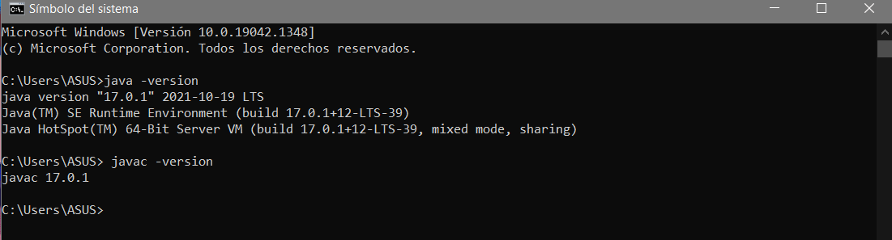

**2 ALTAMIRANO BENALCAZAR CRISTHIAN ALEXANDER**

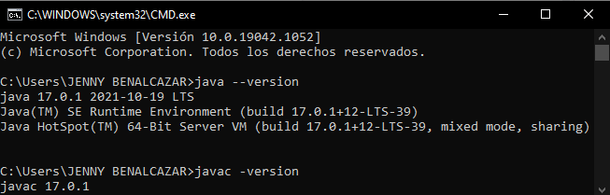

**3 ALVAREZ RAMIREZ MICHELLE ESTEFANIA**

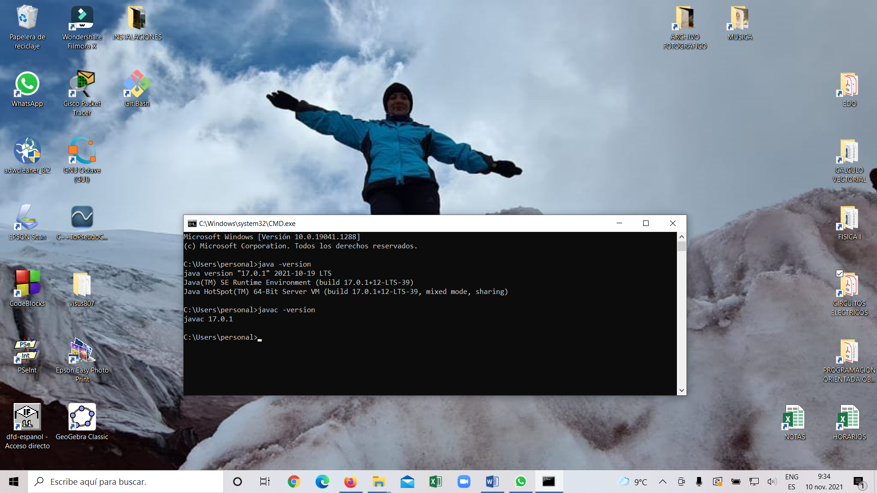

**4 ANDRADE CARATE ALAN DAMIAN**

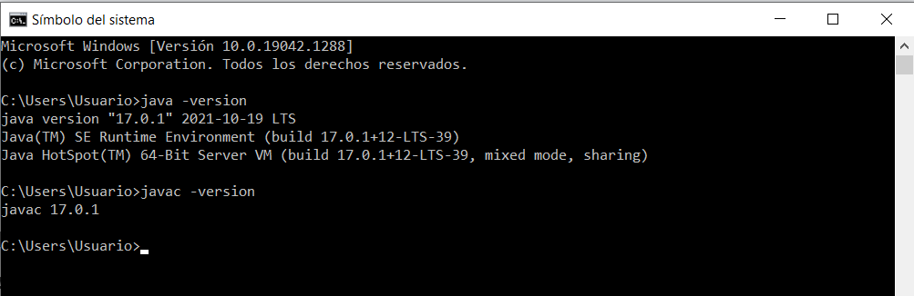

**5 ANDRANGO ESPINOSA ALEX PAUL  
  
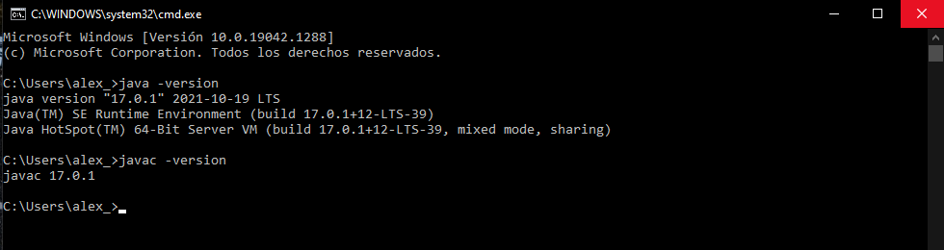**

**6 ARROBA SOLORZANO CRISTIAN ALEXANDER**

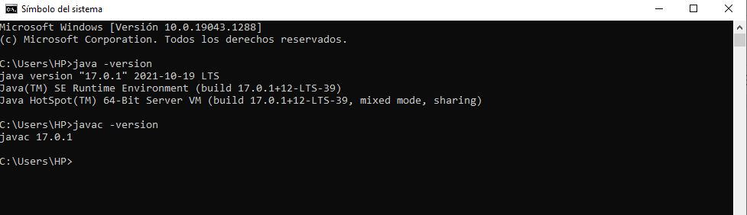

**7 ASUMAZA GUALOTO DYLAN ALEXANDER**

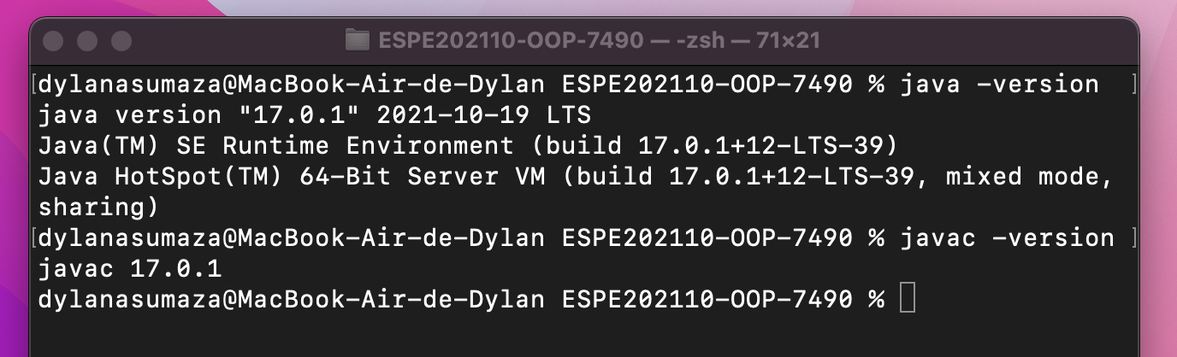

**8 BRAVO RODRIGUEZ KATHERIN DAYANNE**

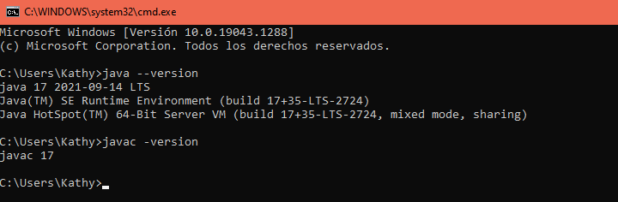

**9 BRAVO VILLALOBOS CHRISTIAN DAVID**

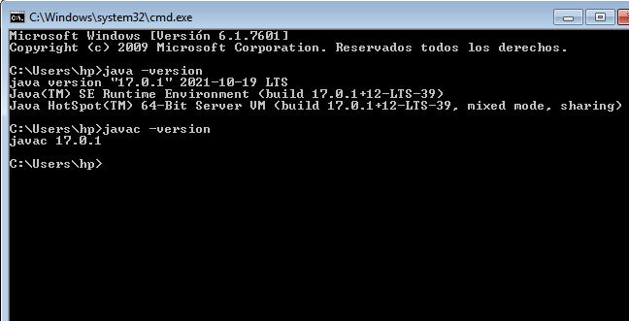

**10 BUSTILLOS MONTENEGRO PABLO SEBASTIAN**

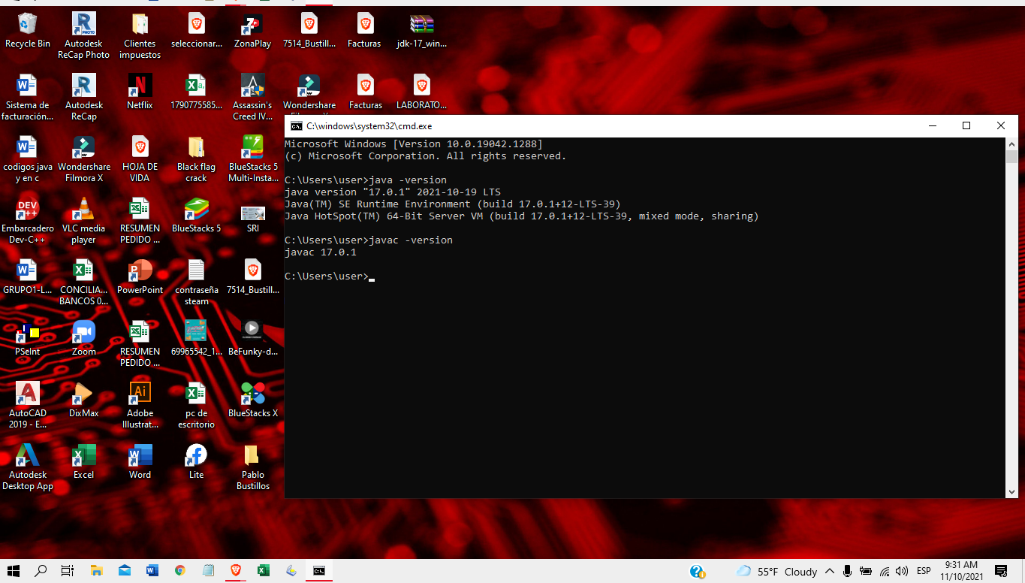

**11 CADENA ROMAN BENJAMIN ABEL**

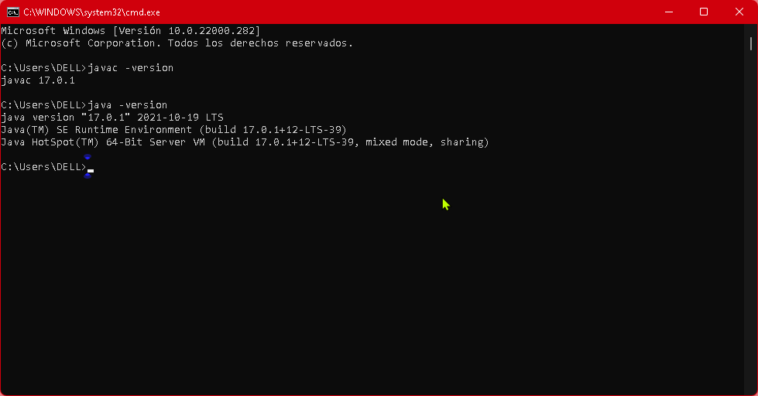

**12 CAISATOA RAMIREZ SEBASTIAN BERNARDO**

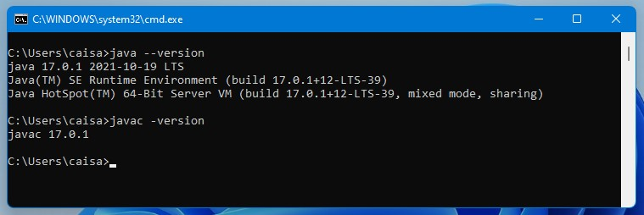

**13 CALDERON MERCHAN ANDY JOSUE**

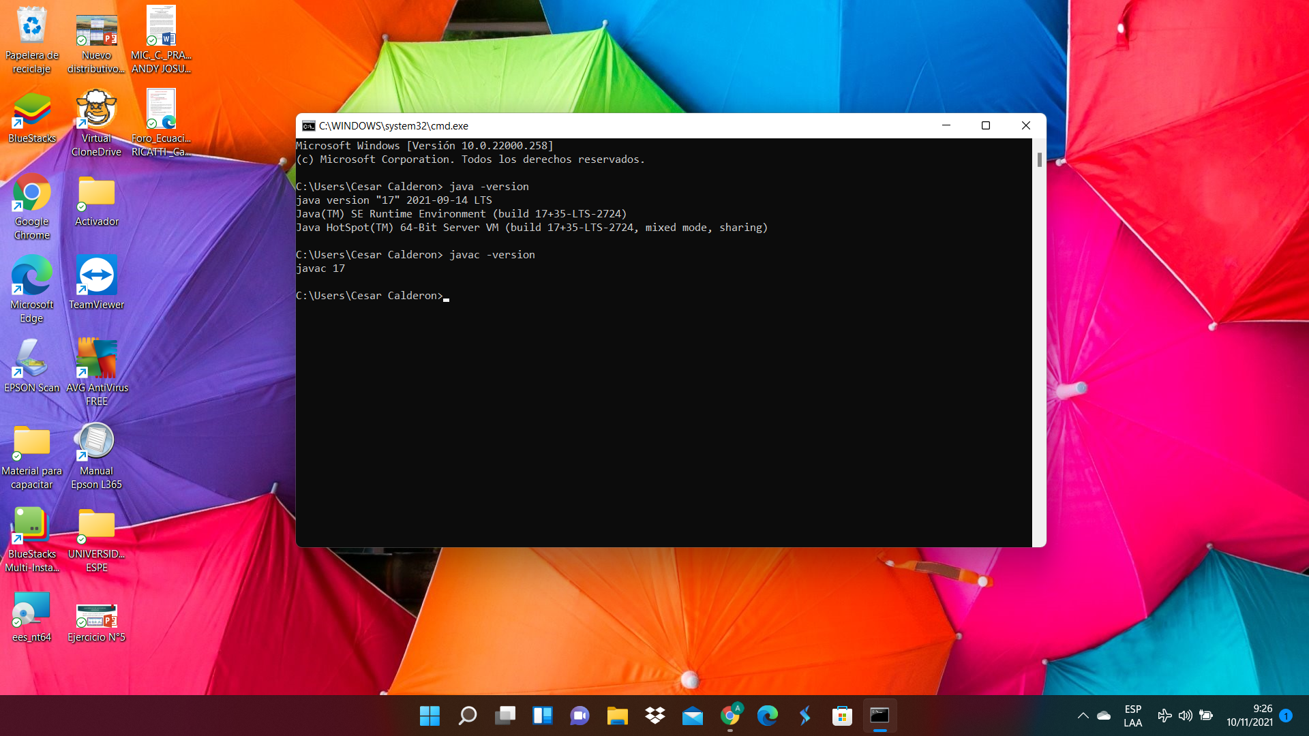

**14 CORREA RUIZ KERLY YADIRA**

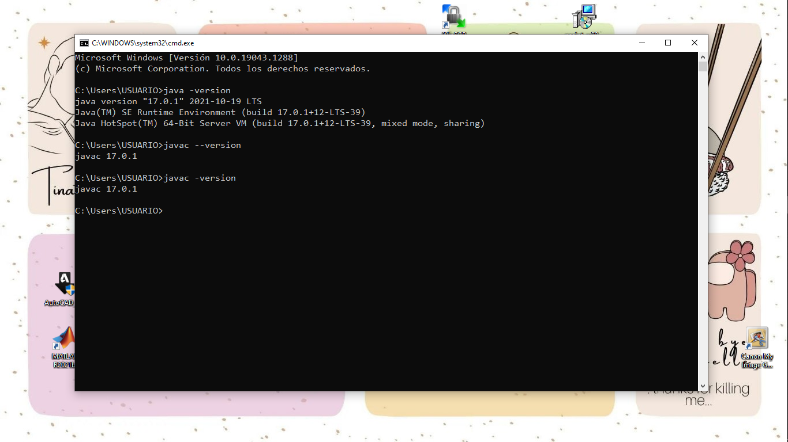

**15 CRUZ PANTOJA DARLING MICAELA**

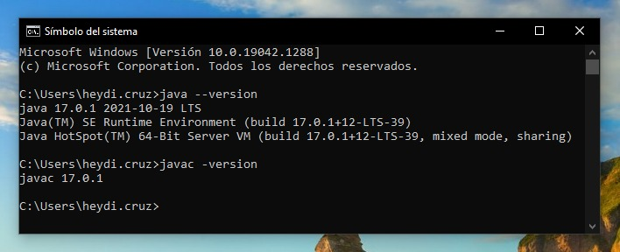

**16 DE LA CRUZ QUINGA ALEJANDRO SEBASTIAN  
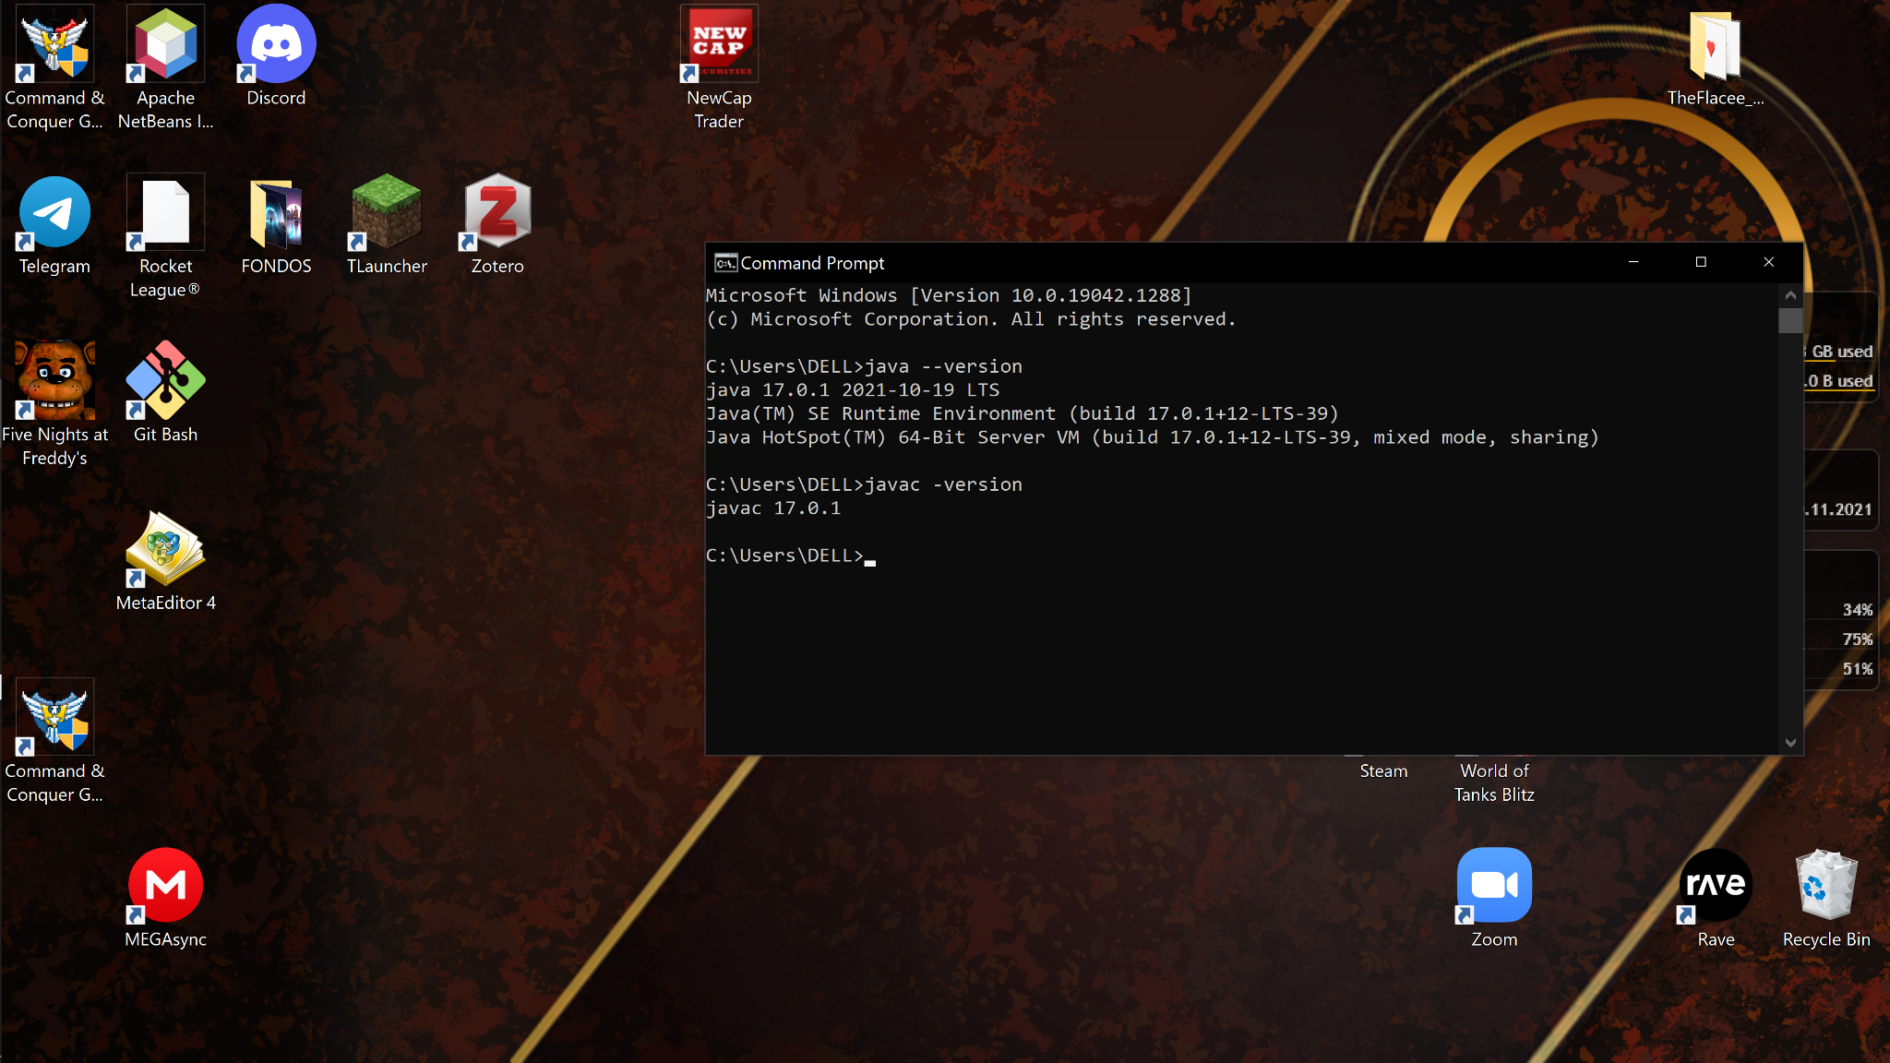**

**17 EIVAR DAGUA JAIME MAURICIO**

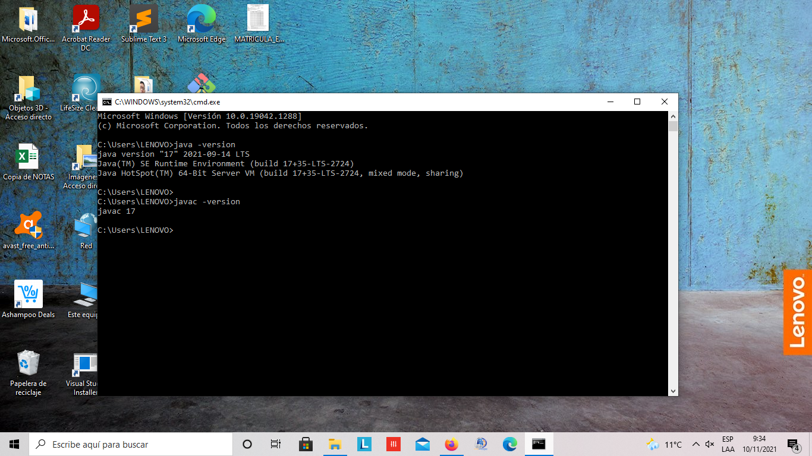

**18 GARCIA BARRETO MAYERLY PRISSILLA**

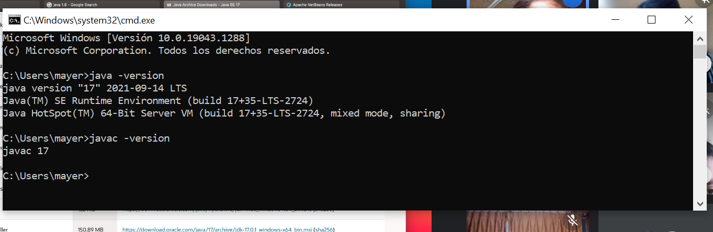

**19 GOMEZ DIAZ MELISSA MALAYCA**

**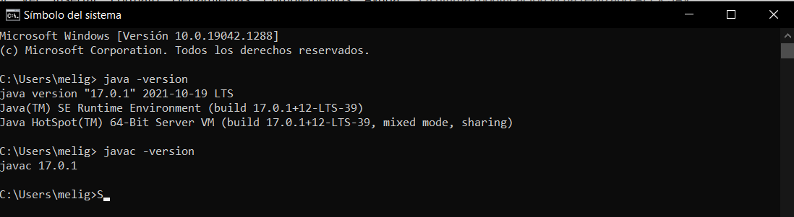  
  
  
  
  
20 GUAMAN VEJARANO ANGEL DAVID**

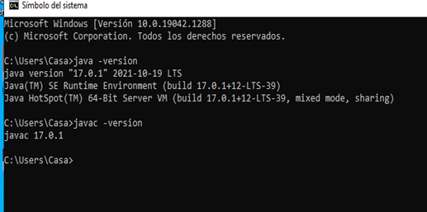

**21 GUITARRA SANCHEZ JHON ALEXANDER**

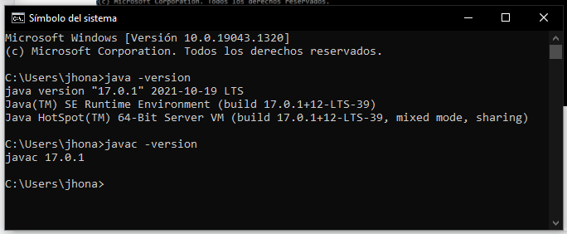

**22 GUZMAN LOPEZ JOSE DAVID**

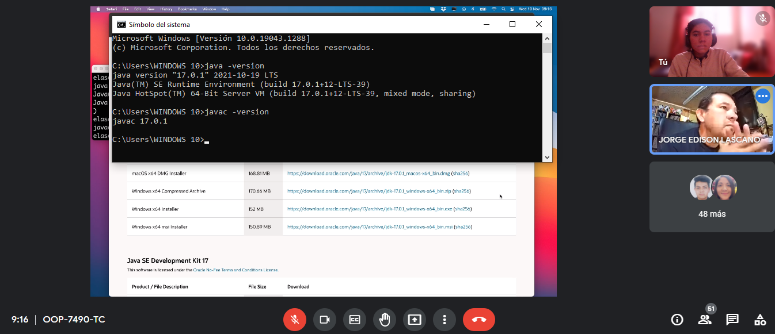

**23 INSUASTI LOPEZ JONATHAN ESTEBA**

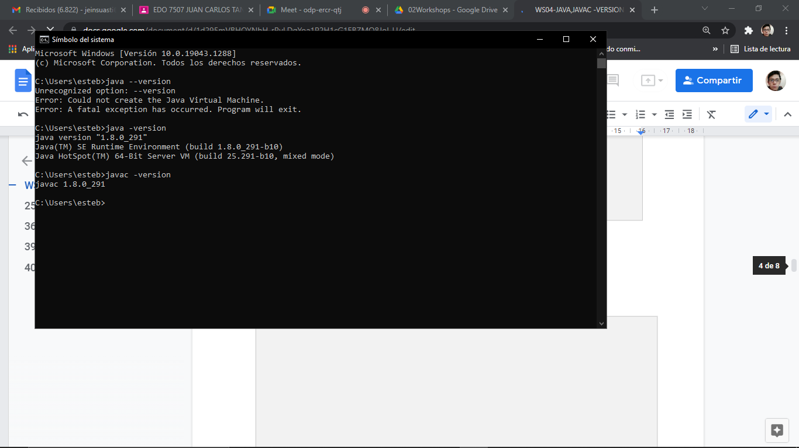

**24 LANDAZURI SEGOVIA MATEO ISRAEL**

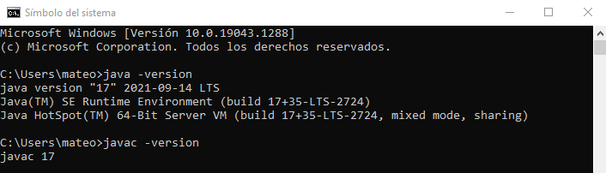

**25 LINCANGO CRIOLLO JOSE DANIEL**

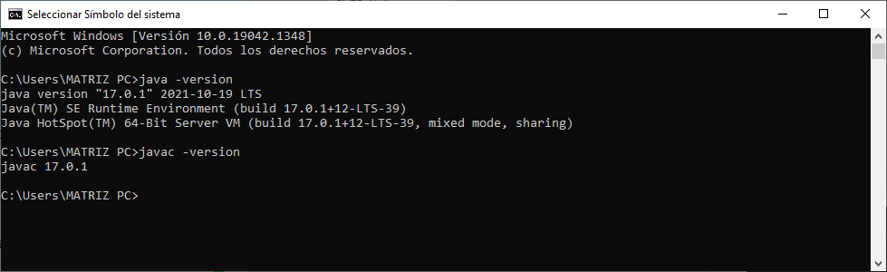

**26 MAISINCHO PAUCAR RICHAR ALEXANDER**

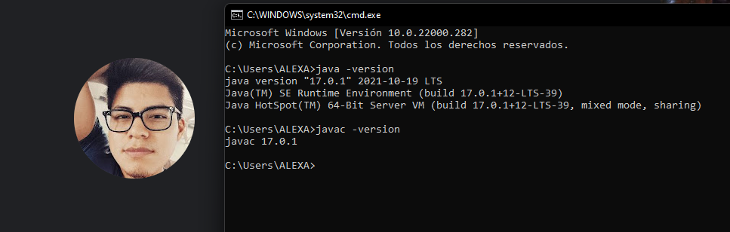

**27 MALDONADO BASTIDAS MATEO STEFANO**

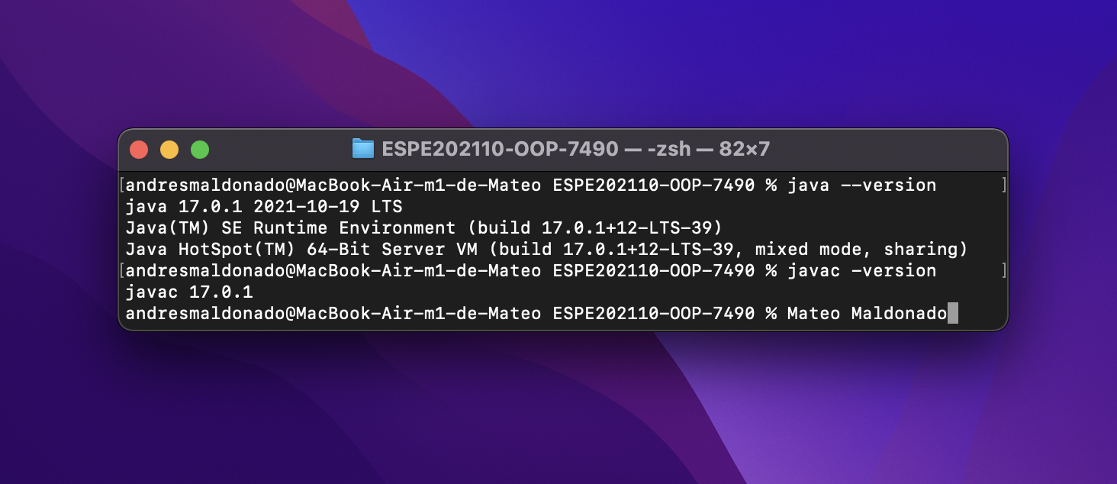

**28 MANTUANO FERNANDEZ LEONEL FERNANDO**

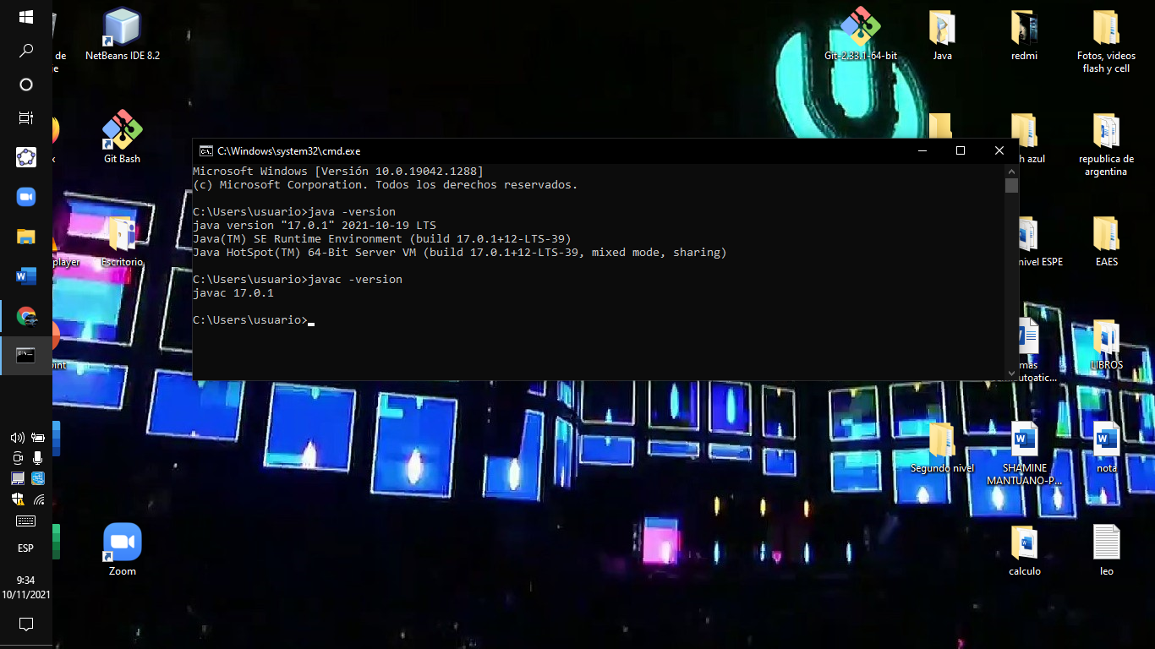

**29 MORALES CAICEDO ANTHONY JAVIER**

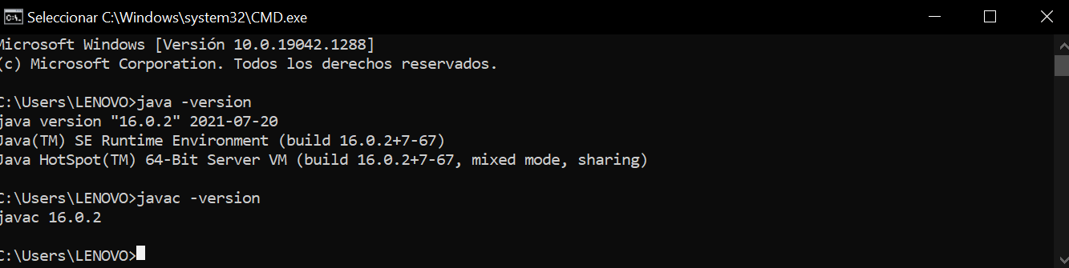

**30 PALACIOS CANDO DIEGO SEBASTIAN**

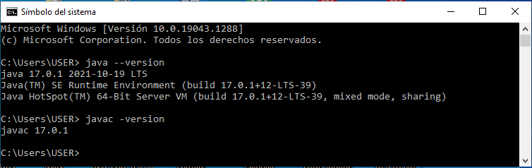

**31 PAUCAR LEMA ALEX JAVIER**

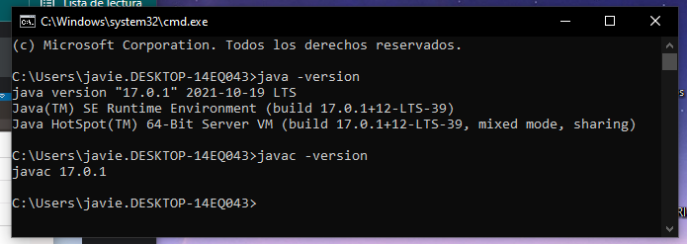

**32 QUINGA GUAYASAMIN LEANDRO ALEXANDER**

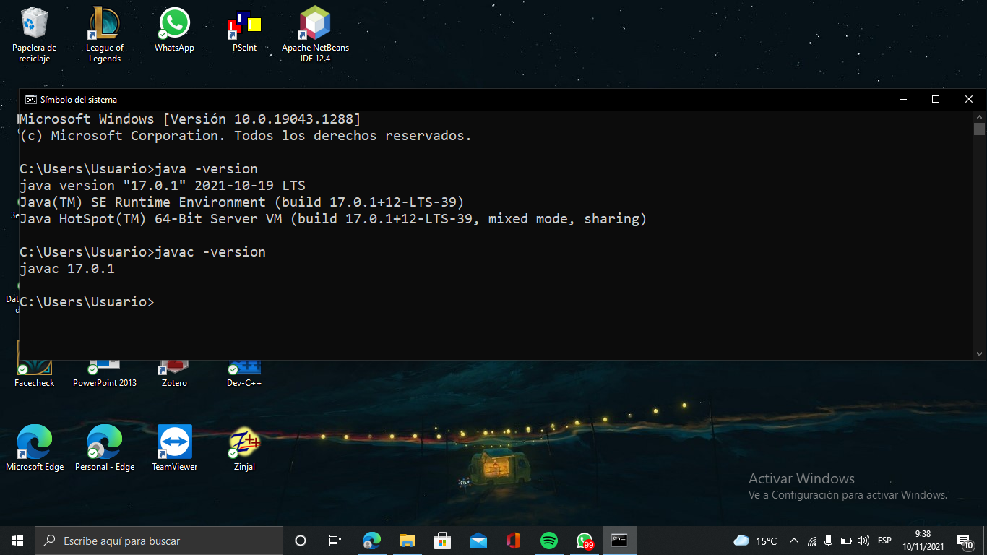

**33 RUANO PONCE ALEXANDER JAVIER**

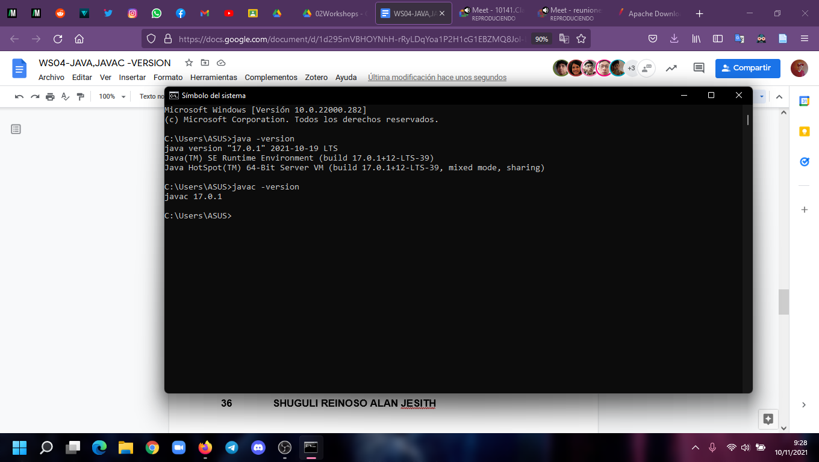

**34 SALTOS TACO PAUL ALEXANDER**

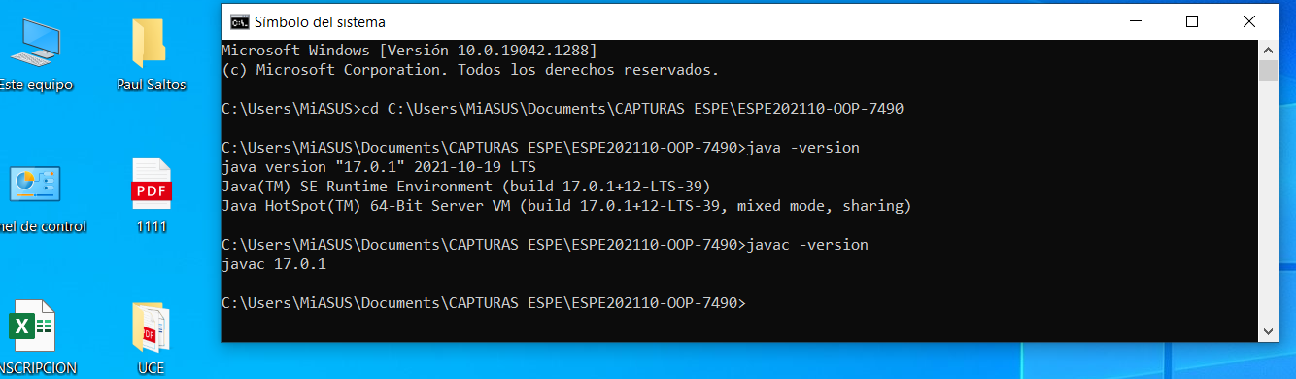

**35 SANCHEZ MISHQUERO JOSE FRANCISCO**

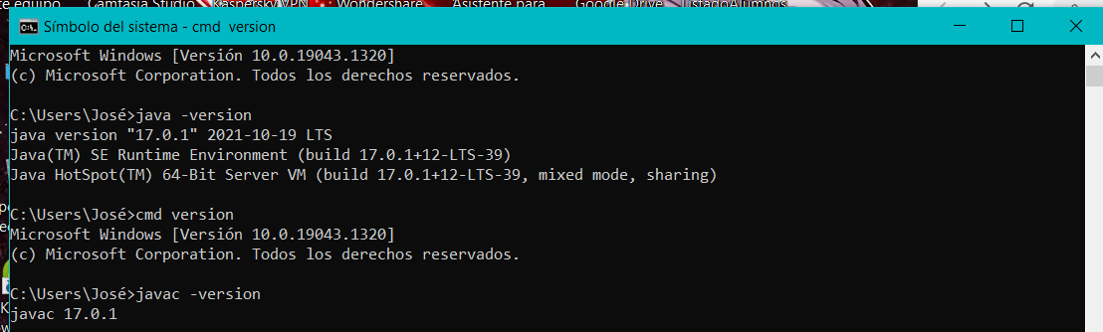

**36 SHUGULI REINOSO ALAN JESITH**

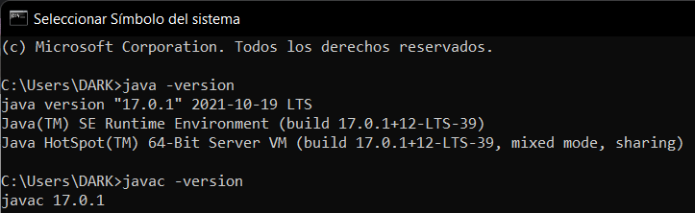

**37 SIMBAÑA SIMBAÑA JONATHAN GUSTAVO**

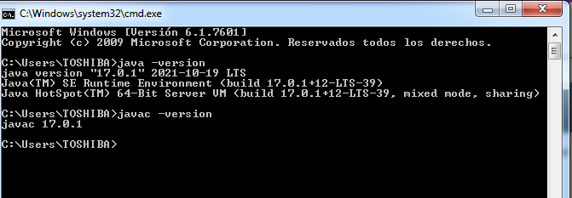

**38 TAPIA ALBAN ANDREA JULIANNA**

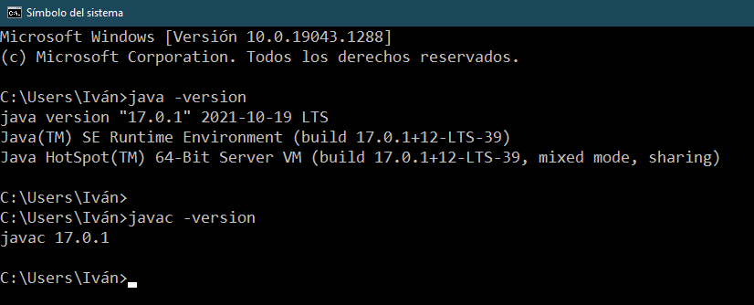

**39 TAYO RUIZ SEBASTIAN ALEJANDRO**

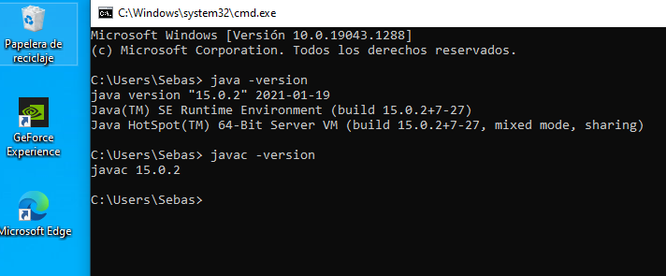

**40 TECA TELLO CAMILA MILENA**

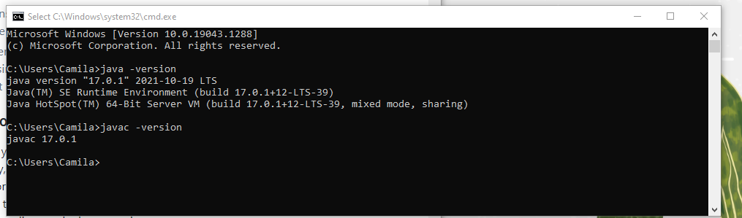

**41 TERAN FLORES MELANIE ELIZABETH**

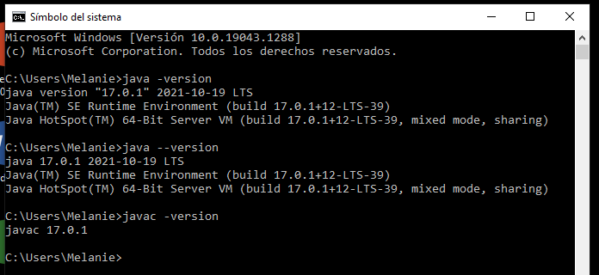

**42 VILLEGAS ESTRELLA SALMA ABIGAIL**

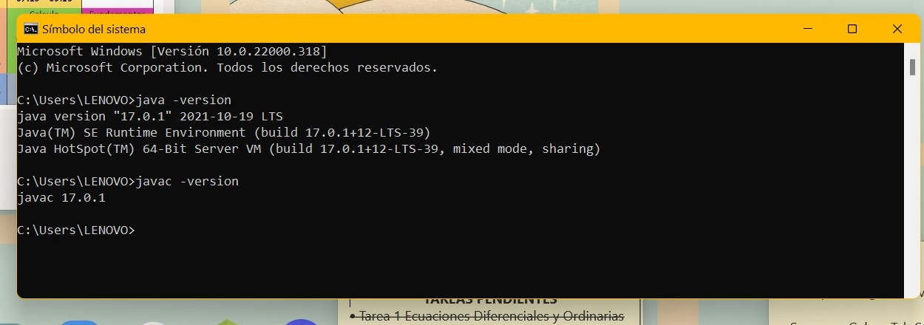

**43 ZEAS CLAVIJO JOEL ALEXANDER**

